RPC WEBPAGE NEWSLETTER
Volume 12, Issue 3 July 2013

Changes in Clinical Trial Digital Radiotherapy Data Submission

The NCI supported clinical trial structure will be changing in 2014 as discussed in our previous RPC Webpage Newsletter (2013 Newsletter Issue 2). The Radiological Physics Center and other QA center staff across the country have been giving presentations outlining the new National Clinical Trial Network (NCTN) and changes to the QA centers. We are pleased to announce a significant data submission change that will be of interest to radiotherapy medical physicists involved in NCI
sponsored clinical trials.
The RTOG recently sent out a news broadcast to its membership detailing a change in the radiotherapy patient data submission process. For the 17 years, the RTOG has accepted both the RTOG format digital data submission as well as the DICOM RT data submission format. The DICOM (Digital Imaging and COmmunication in Medicine) format has been widely adopted in the medical field with DICOM RT adopted by radiation oncology. The DICOM (RT) standard ensures interoperability between digital data processing programs. Currently nearly 90 percent of all RTOG clinical trial patient digital data submissions are submitted as DICOM RT datasets.
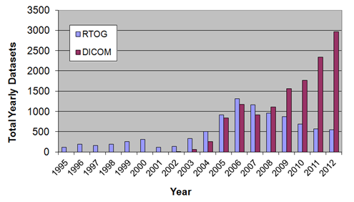

Starting July 1, 2013, all RTOG digital RT data submission will require DICOM (RT) format. The RTOG format will no longer be accepted or supported for RTOG trials.
If you have any questions, do not hesitate to contact the RPC (713) 745-8989.

